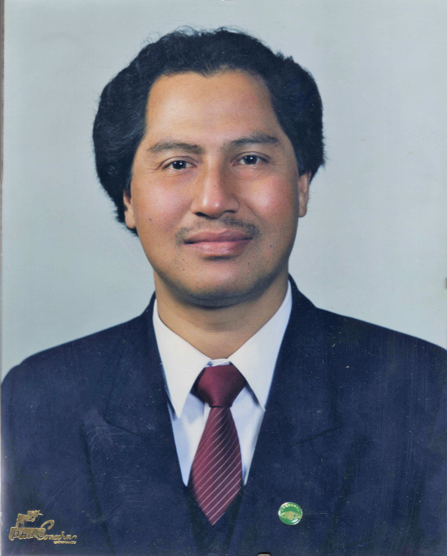

**Profile**

* Over 30 years of Engineering experience in different countries & different capacities.
* (Ex-) Registered and licensed Professional Engineer at Professional Engineer Ontario & Association of Professional Engineers & Geo scientist, British Columbia, Canada.
* Visionary who loves challenges
* Multi linguist (English, Russian, Nepali, Hindi)

**Work History**

**Interpreter : English-Nepali- Russian languages at DiversCity , BC-2013-**

**Energy Management Engineer c/o (in contract with) JTM consulting engineers**

*Power Smart Engineering Lighting division, BC Hydro*, Burnaby, BC  **Nov/2009-2012 December**

* Studied, reviewed, reformatted the spreadsheets to the BCH formatting submitted by local BC Hydro approved consultants for the retrofit projects files from Incentive application to study reports & site inspection all complete. Completed > 200 files for > 100 projects: SUCH, /PSI project/DI Projects both: commercial/Industrial/ building complexes into BC Hydro OTS system. Completed, all together, cumulative: ~ 200 projects.

**Executive Director, Tarapunja Pvt. Ltd Jan2008-Sept/2009**

Worked as the chief Electrical Project /Lighting Engineer: Designed/supervised the energy efficient lighting systems for several building complexes of: Commercial/Industrial/Residential nature, complete with the schedules of quantities, lay out plans. Noteworthy in this context is the: Expo-2010 –Nepal pavilion building complex at Shanghai, PR of China. Completed, all together, cumulative: ~ 06 projects

**Electrical Engineer of Records: Pemco design Ltd, Burnaby, BC** Aug/2006-Oct/2007

Completed, all together, cumulative: ~ 27 projects

**Electrical Engineer 2005**

*Power Smart Engineering lighting division, BC Hydro*, Burnaby, BC

* Compiled data on the cost of lighting systems in BC commercial buildings

Worked under the supervision of Dr. Cristian Suvagau, Ph.D., P.Eng, LC,

President-IESNA-BC

**P. Eng. (Practicum) 2005**

*Power Smart Engineering Lighting division, BC Hydro*, Burnaby, BC

* Assisted in evaluating consultant’s Energy Audit report
* Participated with team surveying energy audit retrofit projects in BC
* Assisted in preparation of seven technical reports on “Electrical Design Guidelines for Power Smart Energy Studies & Projects”

**Engineer-in-Training 2001 - 2002**

*Lumentech Engineers Inc.*, Markham, ON

* Designed the road/traffic/street lighting using Micro-Site-Lite computer program
* Checked shop drawings; liaised with other consultants and clients
* Prepared schedules of quantities along with the relevant specifications
* Visited sites
* Completed, all together , cumulative: ~ 07 projects

**Electric Designer 1999 - 2000**

*The Walter Fedy Partnership*, Kitchener, ON

* Designed the indoor/outdoor lighting, fire alarm system and lightning protection system of commercial and non commercial building complexes
* Prepared schedules of quantities along with the relevant specifications
* Completed, all together , cumulative: ~ 07 projects

**CEO / Chief Engineer 1980 - 1998**

*MK Shrestha & Associates*, Katmandu, Nepal

* Responsible for all engineering activities on 170 residential commercial/non commercial building projects including award winning hotel- Dwarika’s Village, Club Himalaya,Xenial to name a few.
* Prepared designs, drawings, specifications, schedules of materials, budget estimates, tender evaluations, site supervisions, and approved bills
* Liaised with all stakeholders including supervising staff and clients
* Designed and introduced Ring Main and Vertical Rising Main System, reducing implementation and material costs up to 20%
* Trained contractors on the implementation aspects.
* Electrical expert: Council for Technical Education & Vocational Training
* National consultant: National Building Code, building Department: developed electrical installation (wiring) code for Nepal.
* Visiting lecturer to non government organizations both national and international
* National expert for three United Nations Industrial Development Organizations
* Acted as Resource Consultant to 20 International Architectural/Engineering firms
* Electrical Design Engineer: ‘ITECO’ – a Swiss engineering consulting company
* Electrical Engineer: ‘Louis Berger Inc’. – an American engineering consulting company
* Electrical Engineer: ‘March’ a British lighting engineering consulting company: done energy audit - retrofit projects of more than 25 Hotels of Nepal under energy efficiency project under UNDP.
* Completed, all together , cumulative: ~ 175 projects

**Consultant 1988**

*International Labor Organizations,* Katmandu, Nepal

*United Nations Development Programme*

* Electrical Instructor; prepared and delivered 30 lessons to hotel electricians

**Electrical Project Engineer/ Unit-in-charge, Electrical Unit 1979 - 1994**

Department of Housing, Building & Physical Planning, Government of Nepal, Katmandu, Nepal

* Head of the Electrical Unit with engineering and managerial responsibilities
* Prepared layouts, specifications and quantities; tendered documents; awarded contracts for over 150 development projects
* Conducted meetings with other departmental heads and stake holders
* Liaised with many departments including architectural, structural, sanitary, interior design, town planning
* Responsible for the Electrical Investigation Committee for the Chancery Building
* Selected to act as the Counterpart Electrical Engineer for the International Conference & Convention Hall project in Katmandu, Nepal.
* Completed, all together, cumulative: ~ 1000 projects, all over Nepal.

**Education**

**Sustainable Energy Management March 2011- Feb 2012.**

BCIT, Willingdon Ave, Burnaby, BC, Canada.

**Advanced Business Administration** **2005**

*CDI*, Surrey, BC, Canada.

Certificate of Excellence in **Leadership Enhancement Training Project 2003**

Toronto, ON, Canada.

**P.Eng. 2003**

*APEG – BC*, Vancouver, BC, Canada.

**Obligation Certificate with Iron Ring 2002**

*The corporation of the seven wardens Inc., University of Toronto, Toronto, ON,* Canada.

**Administration Management 1983**

*Administration Management Training Centre*, Katmandu, Nepal

**Master in Electrical Engineering** **1976**

*Moscow Power Engineering Institute,* Moscow, Russia

* Specialized in power stations, electrical systems, networks and industrial power supply while Dr V.A. Venikov was head of the department, and Nadejhdin – the Pro rector
* Russian language higher course certification - MPEI 1975
* Social journalist certification- Kuban Agriculture Institute 1971

**Publications / Seminars:**

* Participated: Int’l Asembly & Conference marking the 35th Anniversary of ‘Soviet Alumni Association of Bangladesh (SAAB)’ - 2017.
* Participated : Int’l conference on Literary Society (Nepali) at Tokyo Japan -2015
* More than 10 articles on technical /engineering sciences, including but not limited to: a. Energy conservation a need of time. ’ b. some aspects of lighting & illumination. c. Lightning: why & how & its protection measures. d. Short history of electrical lamp.
* ~50 seminars on the engineering sciences, most of them being in the electrical Lighting business
* Published one technical and 4 general books with ISBN numbers.
* Given several talk programs on technical & non technical subjects.
* Organized “knitting the circle” and the ‘Ekal Sanjh’ (= Solo night) series - a literary & musical fusion program

**Professional Affiliations and Memberships**

* Advisory Board Member: Canadian National Committee/Commission on Illumination
* Side Committee Member: Illuminating Engineering Society of North America, BC Section
* Life Member of many organizations including:

- Mitra Kunj Nepal -Alumni of ex CCCP graduates & founder president -Alumni of ex-CCCP graduates Vancouver/USA Chapter.

Election Commissioner / VP of chapter of the Nepal Engineers Association

- Founding President of the Nepal Illumination Society

- Founding General Secretary of the Society of Electrical Engineers, Nepal

- Founding VP of the Nepalese Canadian Community Services

* Ex-member of many organizations including:
* - Association of Professional Engineers & Geo scientist, British Columbia, Canada.

-Professional Engineers Ontario, Executive board member, East Toronto Chapter-PEO

- Ontario Society of Professional Engineers

- IEEE-Toronto Chapter

- Served as Board Member: Council of Agencies Serving South Asians (NGO)

**Volunteer Work**

Received letters: of excellence/appreciation for:

* Diversity Advisory Committee Member-City of Surrey, BC .
* Member Board of Director _Oak Avenue Neighborhood Hub Society- Surrey, BC.
* Founding President: Canada Nepal Friendship and Cultural Society.
* Founding Vice President Nepalese Canadian Community Services
* Interviewer to APEGBC board for new registrant.
* Presented talk programs, given interviews both here & abroad, Re: Waste to Energy- A high-tech project.
* Hobby: Multi dimensional - multicultural activities: travelling, writing travelogues/memoirs, poems, singing, organizing seminars, talk programs etc.

Noteworthy in this context is the recipient of the prize awarded for the inclusion of my poem into the book (ISBN 978-0-920181-89-8) published by the department of Surrey Art Gallery, the City of Surrey on the Art of Sari dated March 31st-June 24, 2007

**References**: Available upon request.